# Attendee Manager

# The Default Table

The default table view is the table that show in the Active Attendance tab. This Table list all the church attendees that is actively attending church by last name, first name, last date attended and Status.

This table does not have any Filter Options applied to it.

When the program starts this is the table that is displayed.

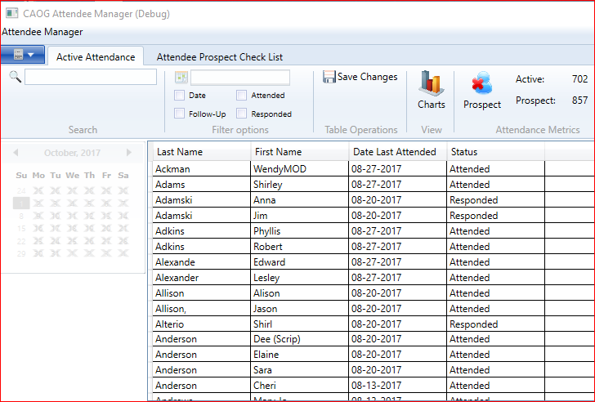

# Filter and search the Default Table

## 2.1 Search the active attendance list

The Default table can be filtered and searched on for specific church attendees.

The user can search a church attendee by typing in the name of the attendee in the search box. The active attendance table will begin the filter all the records with the search text in it. The attendance metrics section will indicate the record count that is shown in the active attendance table.

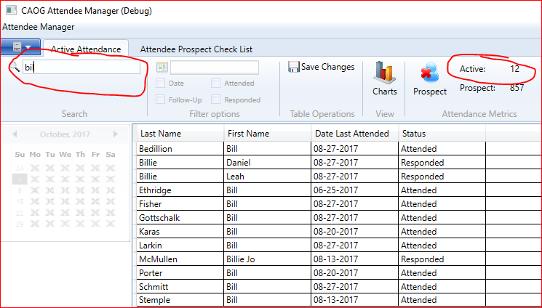

## 2.3 Filter active attendance list by Date, Attended, Follow-Up, Responded

The active attendance list can be filtered by church attendees that attended on a specific date. The list can also be filtered by follow-up or responded.

Note:

The search box has to be empty for you to be able to use the filter options to filter the default table.

Once a filter option is selected, the user can use the search box again to search the filtered table

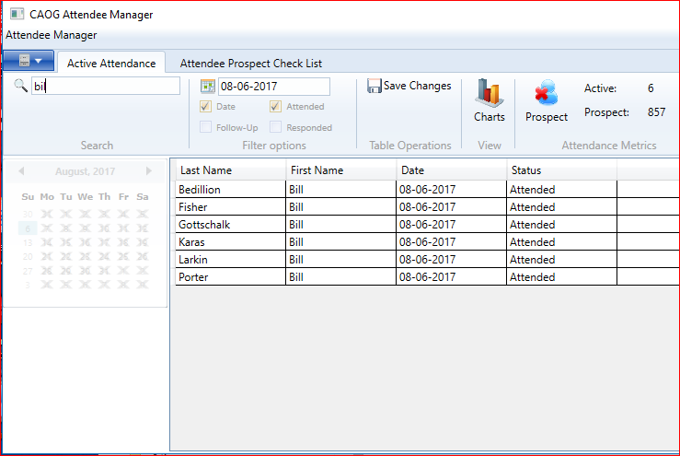

# Edit attendee's name

When in the Active Attendance tab and the table view is the Default view you can edit the name of a church attendee by double click on the Attendee Name and edit it.

Note: You can choose to save your work now or save it later

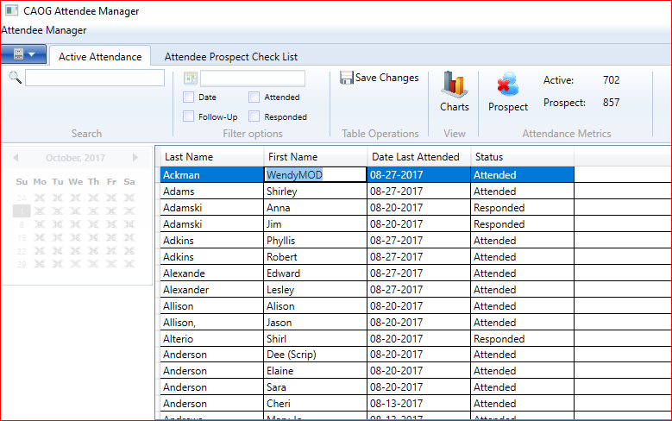

# 4. The Attendee prospect checklist.

In the Attendee Prospect checklist tab, the user can add new attendees or check attendee attendance for a particular Sunday.

## 4.1 Change existing attendees' attendance:

Find the church attendee that attended by searching in the search box or using the scrollbar on the right of the table and check the attended checkbox next to the attendee's name to indicate the attendee attended church.

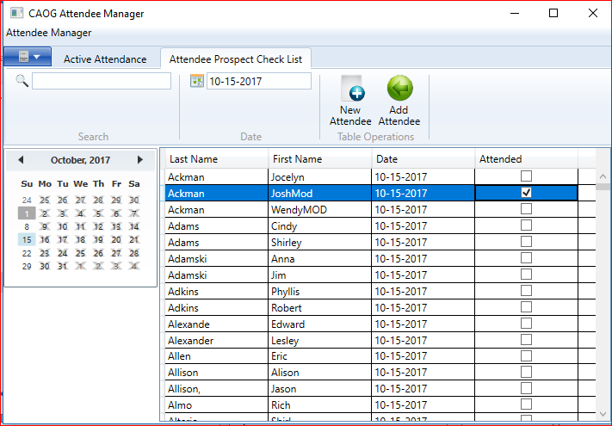

## 4.2 Add new Attendees:

1. Click on the New Attendee button to begin entering new attendees into the table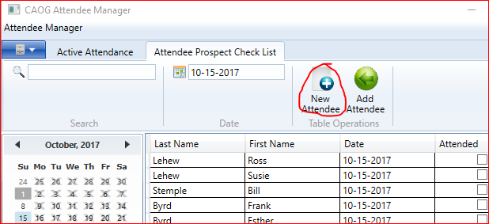
2. Enter all new Attendees's First and Last name in the table followed by a checkmark in the Attended column. Press Enter on the keyboard when done entering the attendee to accept and enter another attendee into the table or mouse click on the empty row to enter another attendee.

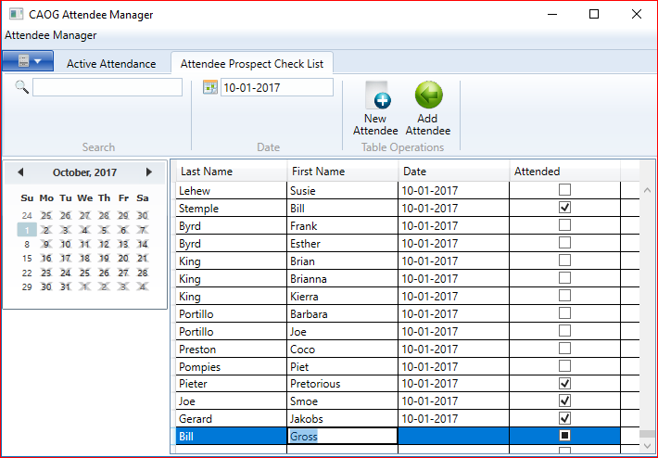

1. After all modifications has been entered into the table choose a date on the calendar for the specific Sunday of attendance.

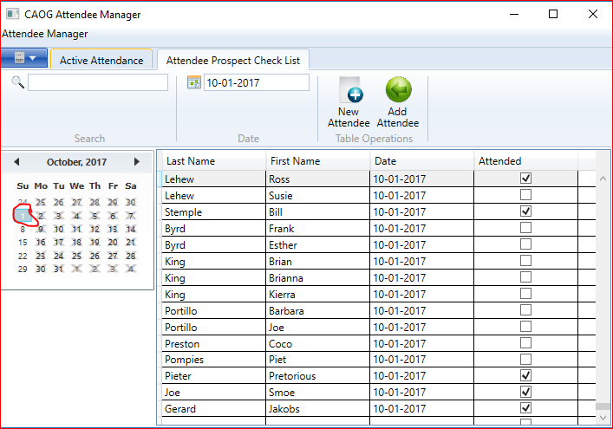

1. Click on the Add Attendee button to add all your modifications you made into to the Active Attendance table in the Active attendance tab.
2. The Active attendance table can now be filtered with the latest modifications.

# 5. Save your changes and generate follow-ups

When you are done with your work, you can hit the Save Changes button to save the Active Attendance table to the Microsoft Azure database in the cloud. Before it saves the table to the database the program will generate follow-up statuses next to each attendee that have missed 3 Sundays of church in a row.

# Mark Active attendees as a prospect attendee

When you no longer want an attendee or multiple attendees to be counted as active church attendees then you can mark the attendee(s) as a prospect attendee (attendee is not actively attended church) by selecting the attendee or attendees in the active attendance table and click on the Prospect button.

A popup message will appear asking the user to confirm the action.

The active attendee counter will decrease and the prospect counter will stay the same indicating the same amount of prospect attendees.

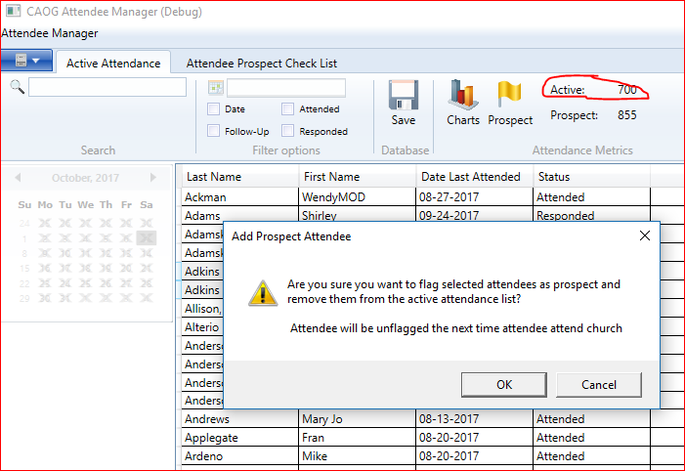

# 7. Multiple Table selection

The user can select multiple attendees by holding down shift and select attendees from the table with the left mouse button or do a control and left mouse select.

# 8. Delete attendees from database

Select multiple attendees in the active attendance table and hit the 'delete' key on the keyboard. This will remove the attendees from the active attendance table but will not remove them from the database until you save your work.

# 9. Save all changes to the database

All the edits you do locally in the Attendee program will not affect the underlying database until you click the Save changes button.